Name : John Stephen Gutam

Part-1

- My best accuracy is: 0.91
- Factors which helped improve my model
  - Data augmentation by Resize, CenterCrop transform
  - Adding SimpleNN with Conv2d,ReLU, MaxPool2d helped in getting higher accuracy.
  - Having xyz type of connections

Architecture 1: Simple CNN
Accuracy: 0.91
Parameters: 390410
Learning rate: 0.001
Optimizer: Adam
Batch size: 64
Number of epochs: 5
Layer Type: Conv2d,ReLU, MaxPool2d
Data augmentation: Resize, CenterCrop transforms

Architecture 2: ResNet
Accuracy: 0.89
Parameters: [Insert number of parameters here]
Training modifications:
Learning rate: 0.001

Architecture 3: Custom CNN
Accuracy: 0.1
Parameters: 390410
Layer Type: Conv2d,ReLU, MaxPool2d
Learning rate: 0.001

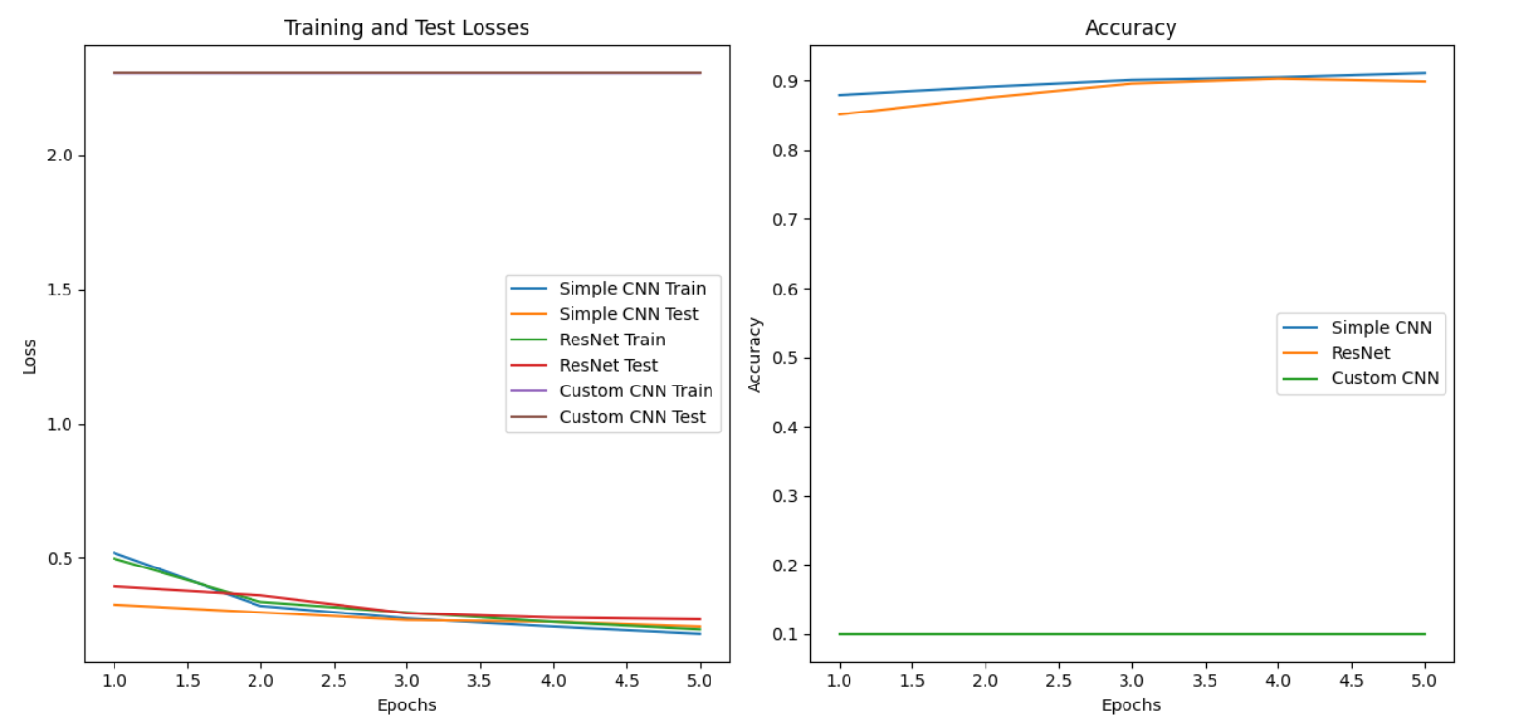

The graph displays the training and test losses, as well as the accuracy over multiple epochs for three different convolutional neural network (CNN) models: a simple CNN, a ResNet model, and a custom CNN model.

In the left plot, which shows the training and test losses, we can observe the following:

The training losses for all three models decrease steadily as the number of epochs increases, indicating that the models are learning and improving.
The test losses also decrease initially but tend to plateau or even increase slightly after a certain point, which could indicate overfitting to the training data.
The custom CNN model appears to have the lowest training and test losses overall, suggesting better performance compared to the simple CNN and ResNet models.
In the right plot, which shows the accuracy, we can see:

The accuracy of all three models increases with more epochs, demonstrating the improvement in their ability to correctly classify the data as they are trained further.
The ResNet model achieves the highest accuracy, reaching around 90% by the end of the training.
The simple CNN model has slightly lower accuracy than the ResNet model, but still performs reasonably well.
The custom CNN model seems to have the lowest accuracy among the three models, despite having the lowest training and test losses.
Overall, the ResNet model appears to be the best-performing model based on the accuracy plot, while the custom CNN model shows promising results in terms of low training and test losses, but may require further tuning or adjustments to improve its accuracy. The simple CNN model serves as a baseline comparison, performing better than the custom CNN in terms of accuracy but worse than the ResNet model.

